**“TOURISM MANAGEMENT SYSTEM”**

**Advance Web Programming Project report submitted**

**In the partial fulfilment the award of degree of**

**BACHELOR OF TECHNOLOGY**

**IN**

**COMPUTER SCIENCE AND ENGINEERING (2022-2023)**

**By**

**T. YADHU VAMSI (211801390029)**

**Under the esteemed Guidance of G. Rama devi, Asst. Professor**



**CENTURION UNIVERSITY OF TECHNOLOGY & MANAGEMENT**

# Vizianagaram, Andhra Pradesh



**CENTURION UNIVERSITY OF TECHNOLOGY &MANAGEMENT**

**Vizianagaram, Andhra Pradesh**

# BONAFIDE CERTIFICATE

This is to certify that the project work entitled **“**TOURISM MANAGEMENT SYSTEM**”** is a fulfilment of project work done by **T. YADHU VAMSI (211801390029)** for the award the degree of **BACHELOR OF TECHNOLOGY** in **COMPUTER SCIENCE AND ENGINEERING,** during academic year 2022-2023.

**INTERNAL GUIDE HEAD OF THE**

**DEPARTMENT**

## G. Rama Devi R. LAXMAN RAO

**M.TECH, (Ph.D.) M.TECH, (Ph.D.)**

**Asst. Professor Asst. Professor**

**Dept. Of CSE Dept. Of CSE**

**EXTERNAL EXAMINER**

## ACKNOWLEDGEMENT

It is with at most pleasure and excitement we submit our project partial fulfilment of the requirement for the award of Bachelor of Technology.

The project is a result of the cumulative efforts, support, guidance, encouragement and inspiration from many of those for whom we must give our truthful honor and

express gratitude through bringing out this project at the outset as per our knowledge.

We convey special thanks to our Project Guide **G. RAMA DEVI, MTech, (Ph.D.)**

Asst.Professor who has guided us and encouraged us to enhance our knowledge with present working of this project to enrich the quality of project.

We expressed our appreciation **to R. LAKSHMANA RAO, M.Tech,(Ph.D)**

Asst.Professor and Head of the Department, who facilitated us to providing a friendly environment which helped to enhance our skills in the present project.

## Table of Contents

Table of

Figure(s)............................................................................................................................ 6

1. Introduction ...................................................................................................................5

1.1 Purpose ....................................................................................................................... 5

1.2 Scope........................................................................................................................... 5

1.3 Definitions, Acronyms and Abbreviations.................................................................. 5

1.4 References................................................................................................................... 5

1.5 Overview .................................................................................................................... 5

2. Overall Description....................................................................................................... 6

2.1 Product Perspective .................................................................................................... 6

2.2 Product functions......................................................................................................... 7

2.3 User Characteristics..................................................................................................... 7

2.4 User Constraints ......................................................................................................... 8

2.5 Assumptions and dependencies................................................................................... 8

2.6 Apportioning of Requirements.................................................................................... 9

1. Specific Requirements .................................................................................................. 9
2. 3.1 External interface.................................................................................................... 9
3. 3.1.1 Web Server .......................................................................................................... 9
4. 3.1.2 PHP Application................................................................................................... 9

3.1.3 MySQL Database .................................................................................................... 9

* 1. Functional Requirements............................................................................................. 10

3.2.1 Use Case Scenario ................................................................................................... 10

3.3 Performance Requirements......................................................................................... 10

1. Requirement Specification............................................................................................ 11
   1. Functional Requirement.............................................................................................. 11
   2. Non Functional Requirement...................................................................................... 11
   3. External interface Requirement................................................................................... 11
   4. Hardware Interface...................................................................................................... 12
   5. 4.5 Software Interface................................................................................................. 12

5.Data Flow Diagram........................................................................................................ 12

5.1 Entity Relationship model........................................................................................... 13

6 Software System Attributes............................................................................................ 16 6.1 Reliability ................................................................................................................... 16

6.2 Availability ................................................................................................................. 16

6.3 Security........................................................................................................................ 17

* 1. Maintainability............................................................................................................. 17
  2. Portability ................................................................................................................... 17

**Table of Figure(s)**

Figure 1: Data Flow diagrams .......................................................................................... 12

Figure 2:ER model............................................................................................................ 15

**1.1 INTRODUCTION**

* 1. **Purpose**

The purpose of a tourism management system is to provide a comprehensive and integrated solution for businesses and organizations in the tourism industry to manage their operations more efficiently and effectively. The system is designed to help businesses automate their processes, reduce manual effort, and streamline their workflow, thus saving time and increasing productivity.

Tourism management systems are important because they help businesses in the tourism industry to stay competitive in a rapidly evolving market. These systems provide a range of tools and features that enable businesses to manage their resources and operations more effectively, which can lead to increased revenue and profitability.

* 1. **Scope**

The scope of a tourism management system can vary depending on the needs of the business or organization, but generally, it encompasses all aspects of managing tourism-related operations.

* 1. **Definitions, Acronyms and Abbreviations**

* + - CRM - Customer Relationship Management
    - ERP - Enterprise Resource Planning
    - PMS - Property Management System
    - API - Application Programming Interface
    - OTA - Online Travel Agency
    - SSL - Secure Sockets Layer
    - POS - Point of Sale
    - XML - Extensible Markup Language
    - UI - User Interface
    - UX - User Experience

**1.4 REFERENCES**

* + - The website of the newspaper delivery service
    - C. Larman, APPLYING UML AND PATTERNS An Introduction to Object-Oriented Analysis and Design and Iterative Development, 3rd ed., Massachusetts: Pearson Education, 2005.D. Carrington, CSSE3002 Course Notes, School of ITEE University of Queensland, 2008IEEE Recommended Practice for Software Requirements Specifications, IEEE Standard 830, 199.

**1.5 OVERVIEW**

This document will provide a detailed description of the functional and non-functional requirements of the tourism management system. It will also include system models and diagrams to help understand the system.

**2.OVERALL DESCRIPTION**

**2.1 Product Perspective**

The software described in this SRS is the software for a complete tourism management system. The system merges various hardware and software elements and further interfaces with external systems. it relies on a number of external interfaces for persistence and unhandled tasks, as well as physically interfacing with humans.

* + 1. **User Interface**

This interface uses the surface computer paradigm - users interact with the system by dragging 'objects' around on the flatscreen touch-sensitive display. For the ORMS, users can manipulate objects such as items of food, dietary requirements, tips and menus on the surface of their table. Such objects can be moved into static objects such as meals and payments to perform various functions. In addition to this object manipulation paradigm, a limited system menu is necessary. Users will summon their restaurant menu, which is combined with a system/command menu, using an easy touch gesture, a double-tap on the touch surface, and dismiss it with a similar gesture or by tapping a close button GUI element.

* + 1. **Hardware Interfaces**

These devices are the surface computers, the wireless tablets and the touch displays. All three devices must be physically robust and immune to liquid damage and stains. The devices (with the possible exception of displays) must also have good industrial design aesthetics, as they are to be used in place of normal restaurant tables and notepads and will be in direct contact with customers.

* + 1. **Software Interfaces**

The RFOS will interface with a Database Management System (DBMS) that stores the information necessary for the RMOS to operate. The DBMS must be able to provide, on request and with low latency, data concerning the restaurant's menu, employees (and their passwords) and available dietary requirements **2.1.5 Communications Interfaces**

The RFOS will interface with a Local Area Network (LAN) to maintain communication with all its devices. It should use a reliable-type IP protocol such as TCP/IP or reliable-UDP/IP for maximum compatibility and stability. All devices it will interface with should contain standard Ethernet compatible, software accessible LAN cards to maintain communication between the server and the surface computers, tablets, displays and the external payment system

**2.2 PRODUCT FUNCTIONS**

The functions of the product are given below:

Tourism Management System Login Information System

* + - Description -The system will maintain the login information of its user to enter in to the software
    - Validating Checks -Administrator need to login the unique id and password. -Contact number should have maximum 10 digits. -All the details must be fill up. -Email address should be in the proper format.
    - Sequencing information -Login information should be filled before the user allowed.
    - Error Handling -If user doesn’t fill up validate information, then the system display error message for user and request to enter the validate information.
    - Performance required Security 10 -System should be Protected from unauthorized access Where the validate Username and Password are required so no other can access.
    - Maintainability -System should be design in a maintain order. So, it can be easily modified.

**2.3 USER CHARACTERISTICS**

**Technical proficiency:**

Users of the system may have varying levels of technical proficiency, so the system should be designed to be user-friendly and intuitive, with a clear and easy-to-use interface.

**Language proficiency:**

Users of the system may speak different languages, so the system should be designed to support multilingual functionality, with options for users to select their preferred language.

**Access requirements:**

Different users may have different access requirements, depending on their roles and responsibilities within the organization. The system should provide user management functionality such as user authentication, access control, and role-based permissions, to ensure that only authorized users can access sensitive data and functionality.

**Time constraints:**

Users may have limited time available to manage their tourism-related operations, so the system should be designed to be efficient and fast, with minimal downtime and delays.

**Mobility:**

Users may need to access the system from different locations and devices, so the system should be designed to be mobile-friendly, with a responsive design that adapts to different screen sizes and devices.

**Security requirements:**

Users may be concerned about the security of their data and transactions, so the system should provide robust security features such as encryption, secure sockets layer (SSL) protocols, and compliance with relevant data privacy regulations.

**Reporting and analytics needs:**

Users may have varying needs for reportingand analytics, depending on their roles and responsibilities within the organization. The system should provide reporting and analytics functionality that is customizable and flexible, allowing users to generate reports and analyze data according to their specific needs.

**Training requirements:**

Users may require training and support in order to effectively use the system. The system should provide training materials and support resources, such as user guides, tutorials, and helpdesk support, to help users learn how to use the system.

**Customer service needs:**

Users may need to provide customer service and support to customers. The system should provide customer relationship management (CRM) functionality that enables users to manage customer interactions and data, including contact information, purchase history, and preferences, to enable personalized marketing and customer service.

**2.4 USER CONSTRAINTS**

GUI is only in English

* Physical limitations.
* Language barriers.
* Time constraints.
* Technical limitations.
* Training requirements.
* Security and privacy concerns.
* Cost constraints.
* Resistance to change.

**2.5 ASSUMPTIONS & DEPENDENCIES** ASSUMPTIONS:

* Customers will pay the bills in online payment.
* Customer can modify their subscription list by sending a request.
* It is assumed that the system never crashes.
* The manager should understand English.
* The manager and customer should be well versed with using a computer.

DEPENDENCIES:

* Modification of subscriptions depends on customer’s request.
* The publications subscribed by the customers depends upon availablility.

**2.6 APPORTIONING REQUIREMENT**

* We can develop our system even further for the customer to avail their subscription facility and modify it online.
* Online Payment by customer.
* Text-to-speech feature.

**3.SPECIFIC REQUIREMENTS**

**3.1 EXTERNAL INTERFACE:**

**3.1.1: WEB SERVER:**

* The web server chosen is Apache:
* Using HTML forms, the user submits data to the web server

The web server runs PHP as a module, and if the post data is accessible, the Popcraft obtains it.

* The PHP script provides data back to the web server.
* The end-user sees an HTML page as a result from the web server.

**3.1.2: PHPAPPLICATION:**

PHP was used to create the actual programme that will carry out the procedures.

A database will be used to store all the data.

1. **1.3: MYSQL DATABASE:**

It’s an open-source SQL database to store all data which communicates with the application on the server.

* 1. **PERFORMANCE REQUIREMENTS:**

Performance requirements are a set of criteria or specifications that specify the speed, capacity, and efficiency with which a system or application must operate. These specifications, which are frequently established by users or stakeholders of the system or application, are used to assess the system's performance and make sure that it satisfies its users' needs.

* + 1. **LOGICAL DATABASE SPECIFICATIONS:**

All information, with the exception of files that are stored on the disc, will be saved in the database, including user accounts and profiles, discussion data, messages, etc. A solid database architecture is necessary for the database to support concurrent access and maintain consistency at all times.

* + 1. **DESIGN CONSTRAINTS:**

1. SQL will be used for all communication between the portal programmed and the database.
2. HTML/CSS will be used to create the portal layout.
3. PHP will be used to create the product.
4. The output needs to be W3C XHTML 1.0 compliant.
5. The source code must adhere to PHP's coding standards.
6. Complete documentation must be available to system administrators.

**3.3 SOFTWARE SYSTEM CHARACTERISTICS:**

The components of the software are as follows:

1.the PHP program and

2.the Apache web server

1. MySQL, the database

1. **REQUIREMENT SPECIFICATION** 
   1. **FUNCTIONAL REQUIREMENT**

The requirement specification aims to outline the essential features and functionalities needed for an effective online restaurant management system.

* + - Allow users to create accounts and register to the system.
    - Verify user identity through email or phone verification.
    - Allow users to login and logout securely.
    - Allow users to modify, pause, or cancel their subscriptions.
    - Provide subscription renewal reminders and alerts.
  1. **NON-FUNCTIONAL REQUIREMENTS:**

Following Non-functional requirements will be there in the online shopping portal.

* + - Secure access of confidential data (customer’s details).
    - 24 X 7 availability.

Better component design to get better performance at peak time.

Flexible service-based architecture will be highly desirable for future extension Non-functional requirements define system properties and constraints It arise through user needs, because of budget constraints or organizational policies, or due to the external factors such as safety regulations, privacy registration and so on. Various other Non-functional requirements are:

* + - 1. Security
      2. Reliability
      3. Maintainability
      4. Portability
      5. Extensibility
      6. Reusability
      7. Application Affinity/Compatibility

**5.DATA FLOW DIAGRAM**

**What it is?**

The Data Flow Diagram shows the flow of data or information. It can be partitioned into single processes or functions. Data Flow Diagrams can be grouped together or decomposed into multiple processes. There can be physical DFD's that represent the physical files and transactions, or they can be business DFD's (logical, or conceptual). Dataflows DFDs show the flow of data from external entities into the system, showed how the data moved from one process to another, as well as its logical storage.

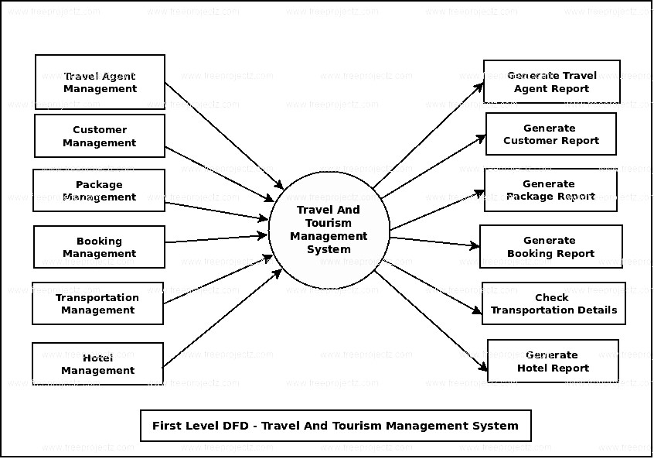

### Figure :1.1Flow chart

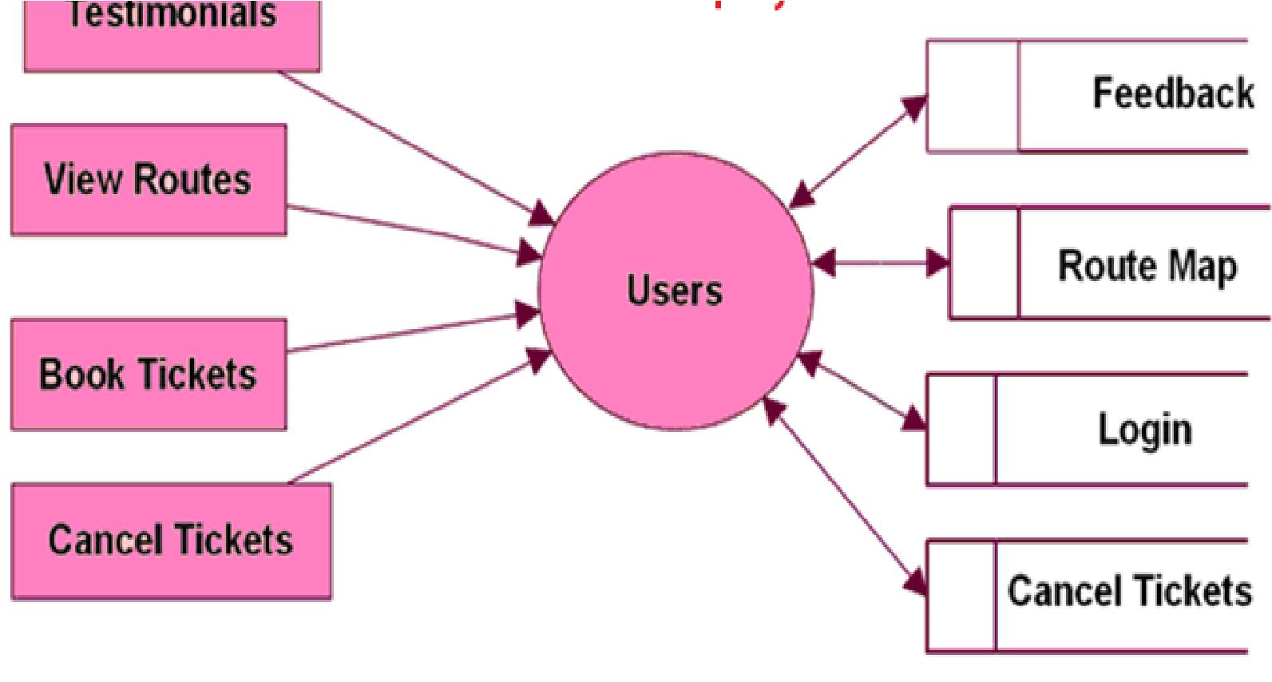

### Figure :1.2 Flow chart for user side

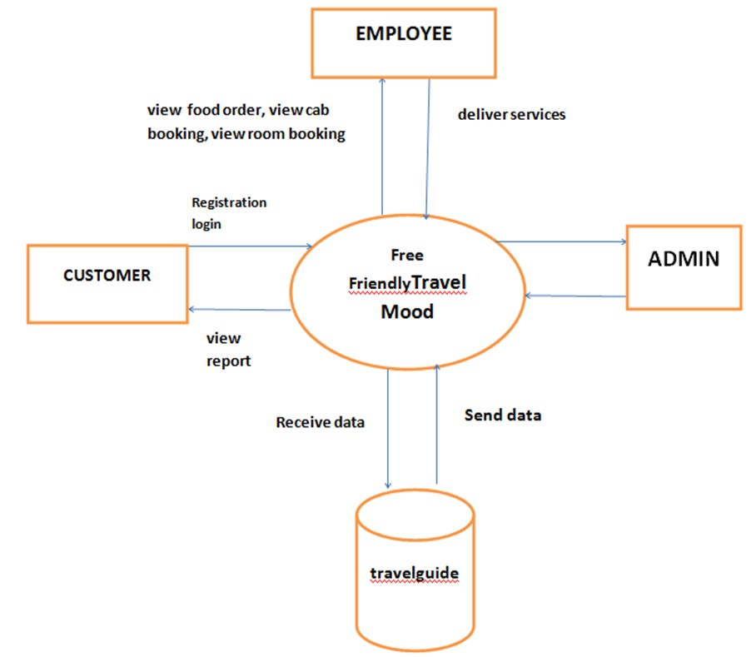

### Figure :1.3 Flow chart for admin

**5.1 Entity-Relationship Model**

Simply stated the ER model is a conceptual data model that views the real world as entities and relationships. A basic component of the model is the Entity-Relationship diagram which is used to visually represent data objects.

**Basic Constructs of E-R Modeling**

The ER model views the real world as a construct of entities and association between entities.

**Entities**

Entitiesare the principal data object about which information is to be collected. Entities are classified as independent or dependent (in some methodologies, the terms used are strong and weak, respectively). An independent entityis one that does not rely on another for identification. A dependent entityis one that relies on another for identification.

**Relationships**

A Relationship represents an association between two or more entities. Relationships are classified in terms of degree, connectivity, cardinality, and existence.

**Attributes**

Attributesdescribe the entity of which they are associated. A particular instance of an attribute is a value. The domain of an attribute is the collection of all possible values an attribute can have. The domain of Name is a character string.

**Classifying Relationships**

Relationships are classified by their degree, connectivity, cardinality, direction, type, and existence. Not all modeling methodologies use all these classifications.

**Degree of a Relationship**

The degree of a relationship is the number of entities associated with the relationship. The n-ray relationship is the general form for degree n. Special cases are the binary, and ternary, where the degree is 2 and 3 respectively.

**Connectivity and Cardinality**

The connectivity of a relationship describes the mapping of associated entity instances in the relationship. The values of connectivity are "one" or "many". The cardinality of a relationship is the actual number of related occurrences for each of the two entities. The basic types of connectivity for relations are: one-to-one, one-to-many, and many-to-many.

**Direction**

The direction of a relationship indicates the originating entity of a binary relationship. The entity from which a relationship originates is the parent entity; the entity where the relationship terminates is the child entity.

The direction of a relationship is determined by its connectivity type. An identifying relationshipis one in which one of the child entities is also a dependent entity. A nonidentifying relationshipis one in which both entities are independent.

**Existence**

Existencedenotes whether the existence of an entity instance is dependent upon the existence of another, related, entity instance. The existence of an entity in a relationship is defined as either mandatory or optional.

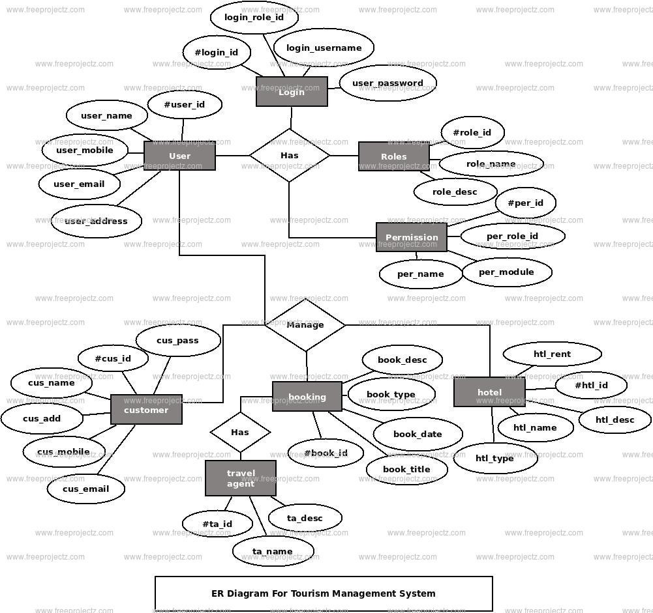

### Figure 2.1: ER Diagram

**Use Case Diagram**

A use case describes a sequence of actions that provide something of measurable value to an actor and is drawn as a horizontal ellipse an actor is a person, organization, or external system that plays a role in one or more interactions with your system.

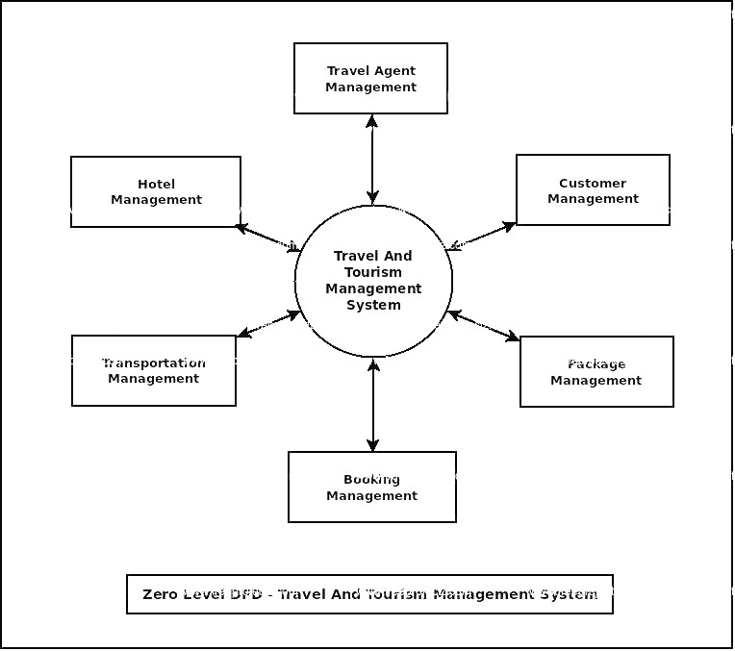

**Figure 2.2: Use Case Diagram**

**6.Software System Attributes**

**6.1 Reliability:**

* + The system should operate consistently and reliably without unexpected errors or failures.
  + It should be able to handle high loads and maintain performance under various conditions.

**6.2 Availability:**

The system should be available to users as per the defined service level agreements (SLAs).

It should minimize downtime and provide a high level of uptime.

**6.3 Security:**

The system should implement robust security measures to protect user data and ensure confidentiality.

It should have mechanisms to prevent unauthorized access, data breaches, and other security threats.

**6.4 Maintainability:**

The system should be designed to be easily maintainable and modifiable.

It should allow for efficient bug fixing, updates, and enhancements without disrupting the overall functionality.

**6.5 Portability:**

The application is windows -based and should be compatible with other systems. Apache, PHP and MySQL programs are practically independent of the OS-system which they communicate with. The end-user part is fully portable and any system using any web browser should be able to use the features of the application.